Title of the Lesson: 
Cohort:
Dates:
Theme:
Week:
Learning Outcomes:
Example: Child engages in and maintains positive interactions and relationships with other children. (P-SE 3)

Fill in your group ____________Cohort
Remote Lesson Plan Grid (English)
Title of the Lesson:  Theme:  Week:  Learning Outcome: | 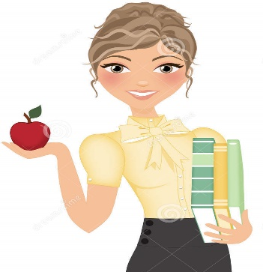    Cohort  Lesson Designers  1.  2.  3.  4.  5.  6.  7.  Cohorts YouTube Videos English and Spanish
Wonderful Words of the Week:

Opening Song  Use Your Classroom Mascot! | Materials inside your Materials Box
Procedures

Product Outcome:
(Pictures)

Questions to ask Before, During and After Your Lesson
Use your Classroom Mascot!

Before:

During:

After:
Parent Tips on Milestones/Adaptations | Song/s related to the Theme
Parent Tips on Milestones/Adaptations | Closing Song  Use your Classroom Mascot!!
Remote Lesson Reflections

EHS Remote Implementation FLEX Lesson Plan
Video Overview
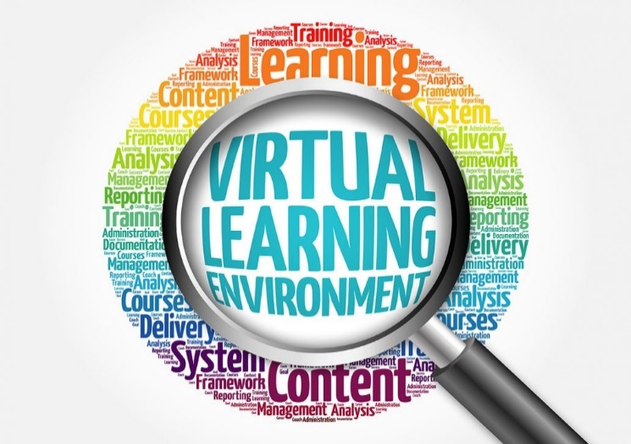
Follow the Lesson Plan
Be sure to have your Written Lesson Plan with you to help you prepare your lesson delivery.
Professional Attire
Wear your EHS School Shirt. Look and be your best when you are remotely visiting with your children and videoing your lesson. You are a role model!!
Follow the Video Rubric
Have the rubric in front of you in order to follow the steps as you video your lesson.
Example: Opening/Closing Song, the purpose of your visit and objective. Use the lesson plan as your checklist, before and after the recording.
Upload Your Video to A Platform of Your Choice
YouTube or One Drive? Forward your video and remember to send the final copy to the UTRGV OneDrive.

Thank You for moving mountains to teach our EHS children and families from a distance.

Teacher Notes
___________________________________________________________________________________________________________________________________________________________________________

